Adapting HPVsim to model HPV transmission, cervical cancer diagnoses and different public health interventions in high-income countries: modelling study for England, Supplementary Materials

S1: Non-Calibrated Model Parameters

Initial HPV prevalence for women by age bracket is informed by WHO data for England (https://hpvcentre.net/statistics/reports/GBR.pdf?t=1667160001618, Figure 54). Data for men is informed by USA estimates (https://doi.org/10.1093/infdis/jix057, Figure 2).

Initial HPV Prevalence by Sex and Age Group, over all Genotypes
Age (years) | 0-16 | 17-24 | 25-34 | 35-44 | 45-54 | 55-64 | 65+
Initial Female HPV Prevalence | 0 | 0.25 | 0.14 | 0.08 | 0.06 | 0.06 | 0.03
Initial Male HPV Prevalence | 0 | 0.20 | 0.23 | 0.20 | 0.18 | 0.25 | 0.25

We calibrate the below parameters, with two highly variable depending on social setting (requiring calibration when fitting to the new setting of England), and the beta parameter a core parameter necessitating calibration.
Calibrated Parameters relating to HPV transmission, excluding genotype-specific parameters
Parameter Name | Parameter Interpretation | Prior | Lower Bound | Upper Bound
f cross layer | Proportion of female agents who have concurrent cross-layer relationships | 0.15 | 0 | 1
m cross layer | Proportion of make agents who have concurrent cross-layer relationships | 0.25 | 0 | 1
beta | Per-act probability of HPV transmission | 0.25 | 0 | 0.5

HPV DNA test characteristics are informed by the meta analyses of Mustafa et al (https://pubmed.ncbi.nlm.nih.gov/26851054/).

Model of HPV DNA test characteristics.
Agent State | Outcome Distribution
Agent State | Positive | Negative
Susceptible | 0.12 | 0.88
Latent | 0.12 | 0.88
Precin | 0.94 | 0.06
CIN | 0.94 | 0.06
Cancerous | 0.94 | 0.06

Cytology characteristics are informed by analyses in high income settings, performed by Koliopoulos et al (https://pmc.ncbi.nlm.nih.gov/articles/PMC6483676/).

Model of Cytology characteristics.
Agent State | Outcome Distribution
Agent State | Normal | Abnormal
Susceptible | 0.96 | 0.04
Latent | 0.96 | 0.04
Precin | 0.96 | 0.04
CIN | 0.3 | 0.7
Cancerous | 0 | 1

Meta analysis finds colposcopy sensitivity at 0.95 and specificity at 0.42 (https://pubmed.ncbi.nlm.nih.gov/26851054/). Our modelling only acts on three outcomes from colposcopies - 'hsil' (prompting ablation) or 'cancer' (prompting general cancer treatment), or 'normal' (prompting no treatment). Our probabilities are informed by these reported sensitivities and specificities, and additionally agree with the work of Brown and Tidy (https://doi.org/10.1016/j.ejogrb.2019.07.003; using their second definition of colposcopy outcomes).

Model of Colposcopy characteristics.
Agent State | Outcome Distribution
Agent State | Normal | Abnormal: HSIL | Abnormal: Cancer
Susceptible | 0.7 | 0.3 | 0
Latent | 0.6 | 0.4 | 0
Precin | 0.42 | 0.58 | 0
CIN | 0.05 | 0.95 | 0
Cancerous | 0 | 0.05 | 0.95

S2: Calibration Results
The parameter samples and associated GOF values arising from calibration are available on the GitHub: https://github.com/fabiansturman/HPVScreeningProject/.

Below, we report goodness of fit to seen and unseen cervical cancer incidence data, and to seen cervical cancer genotype distribution data. Age brackets are in 5-year intervals (0-5,5-10, 10-15, etc). Genotypes are 16, 18, hi5, and ohr.

  - Fit to seen data, 2011-2018
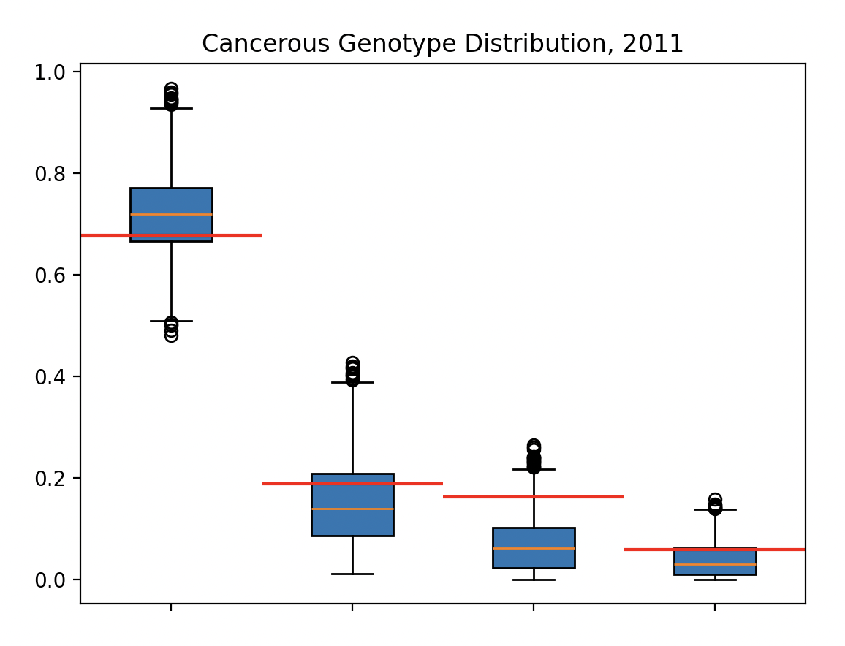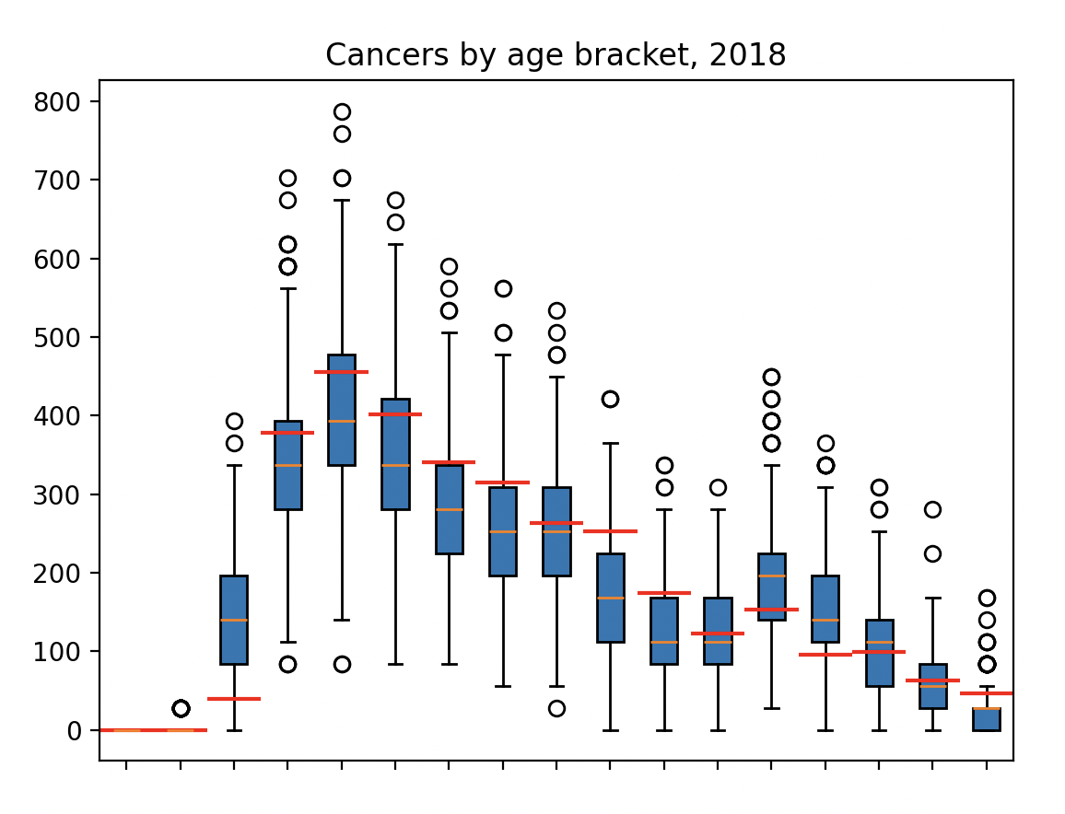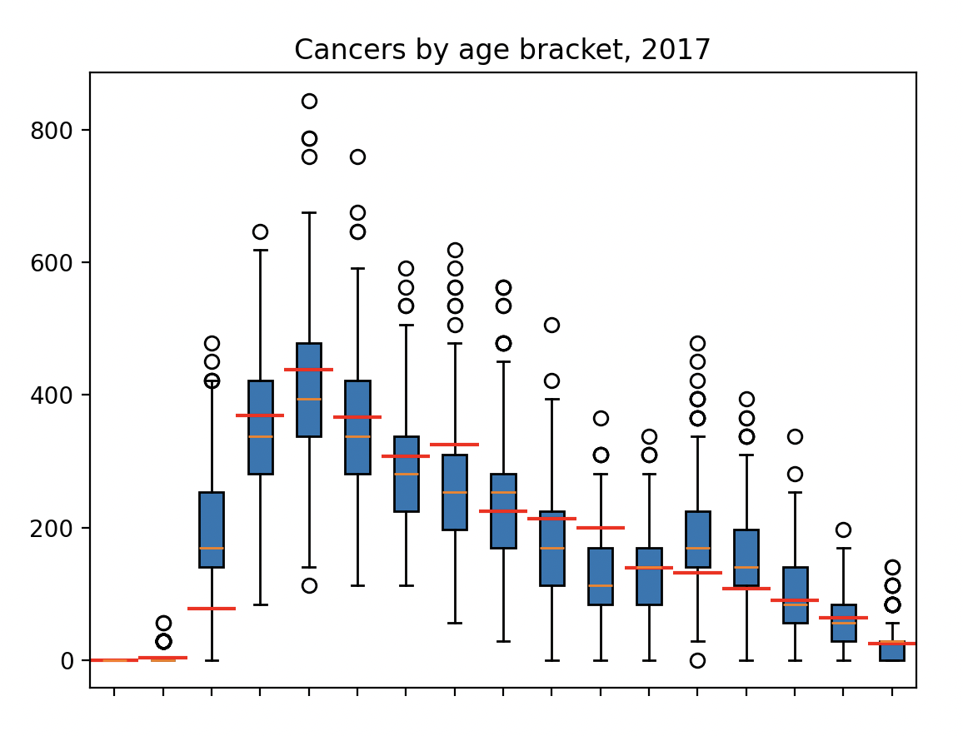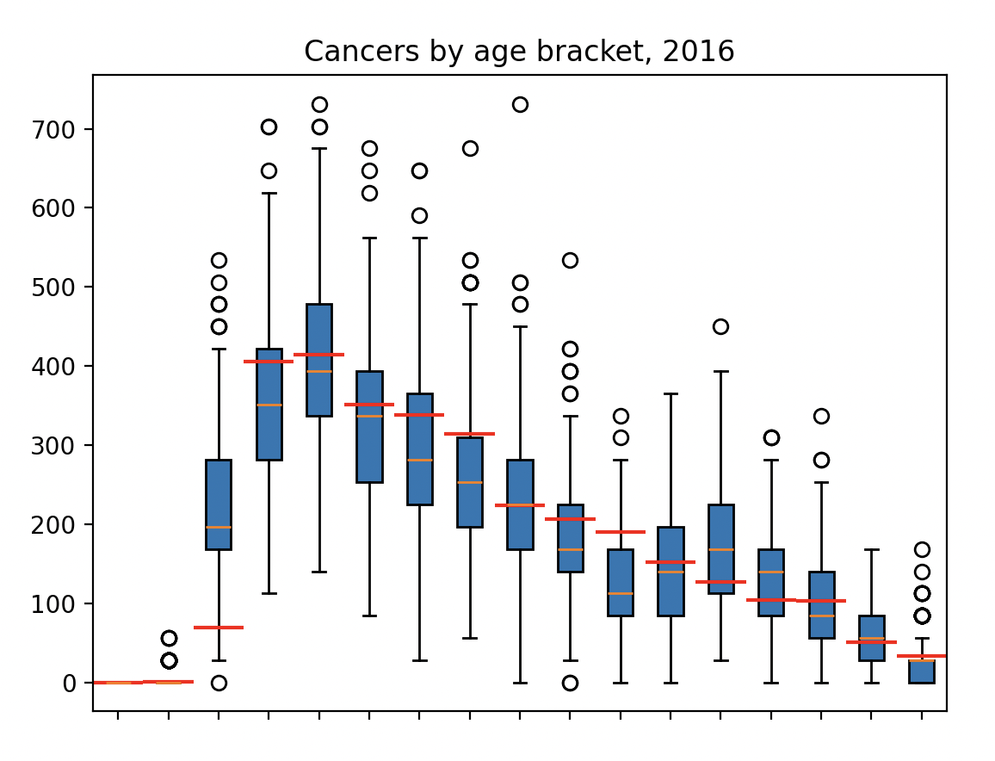
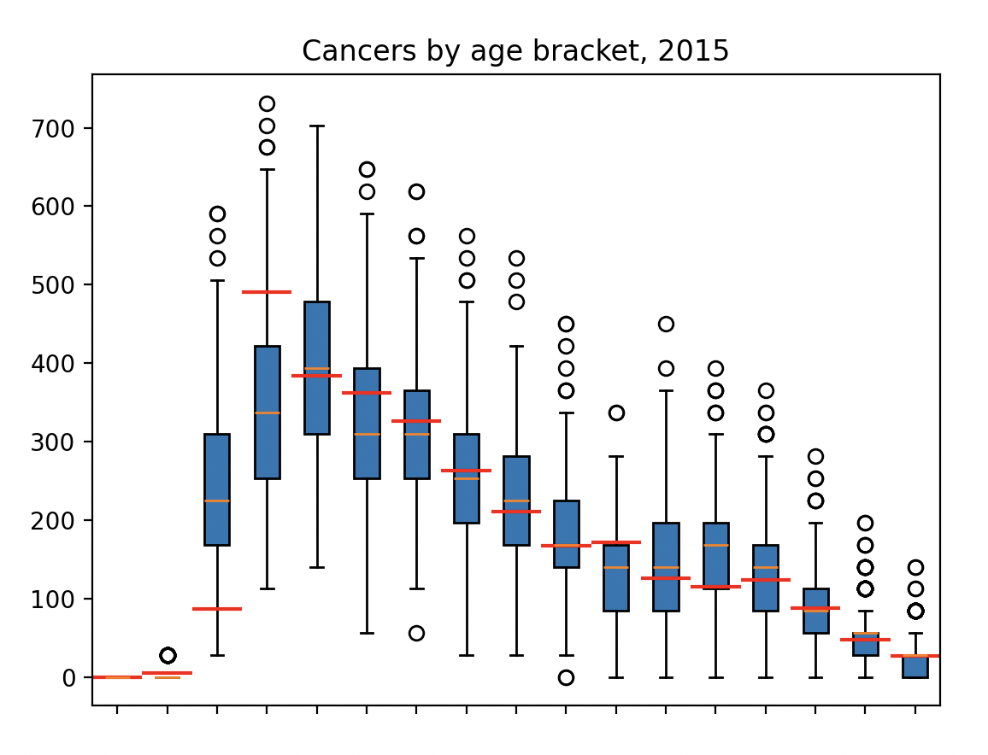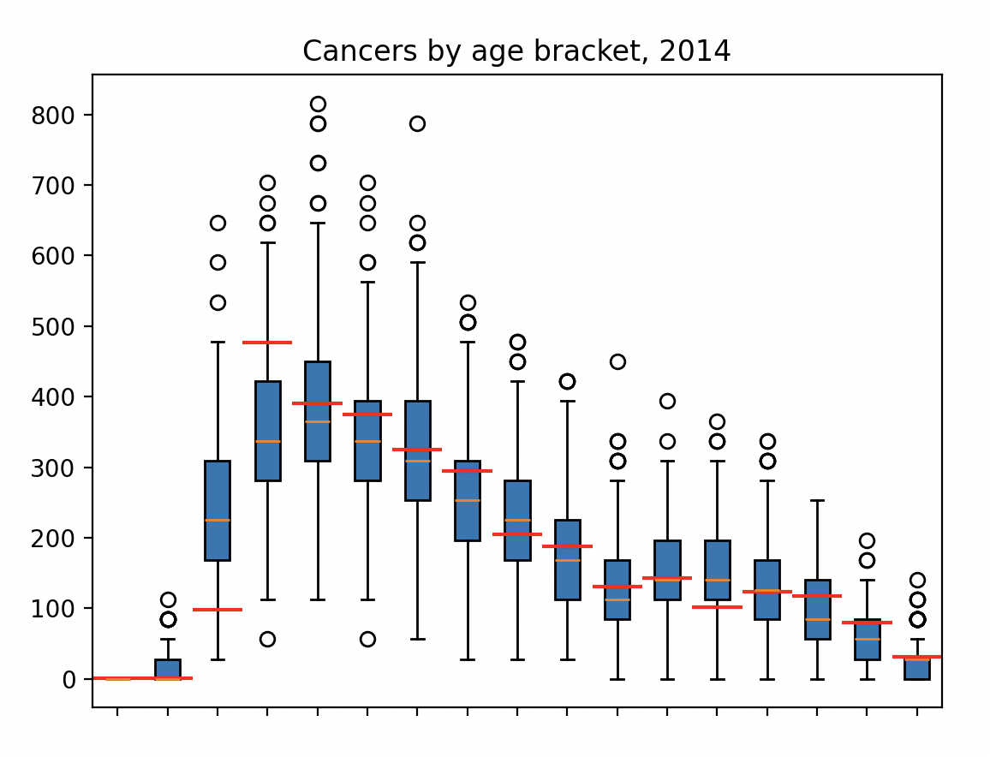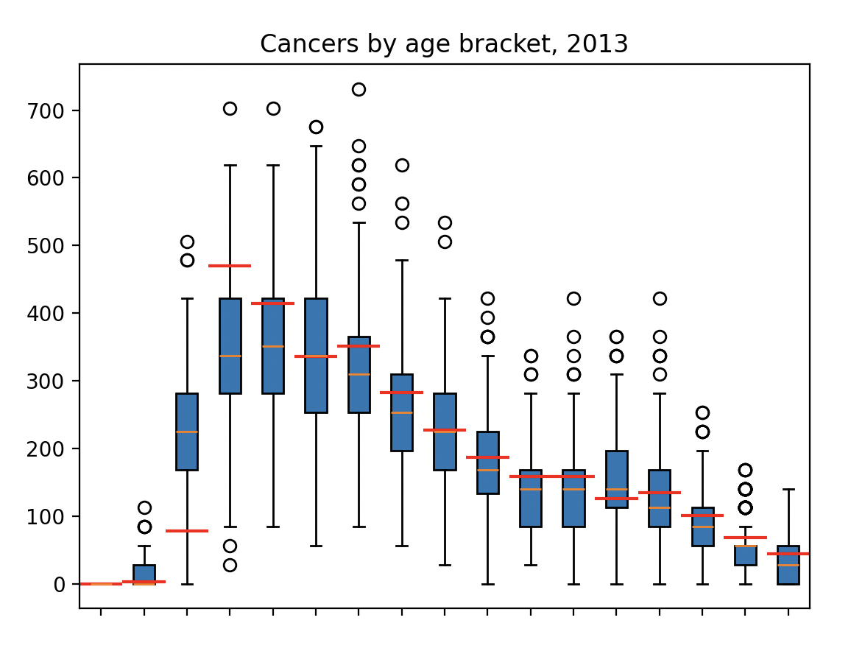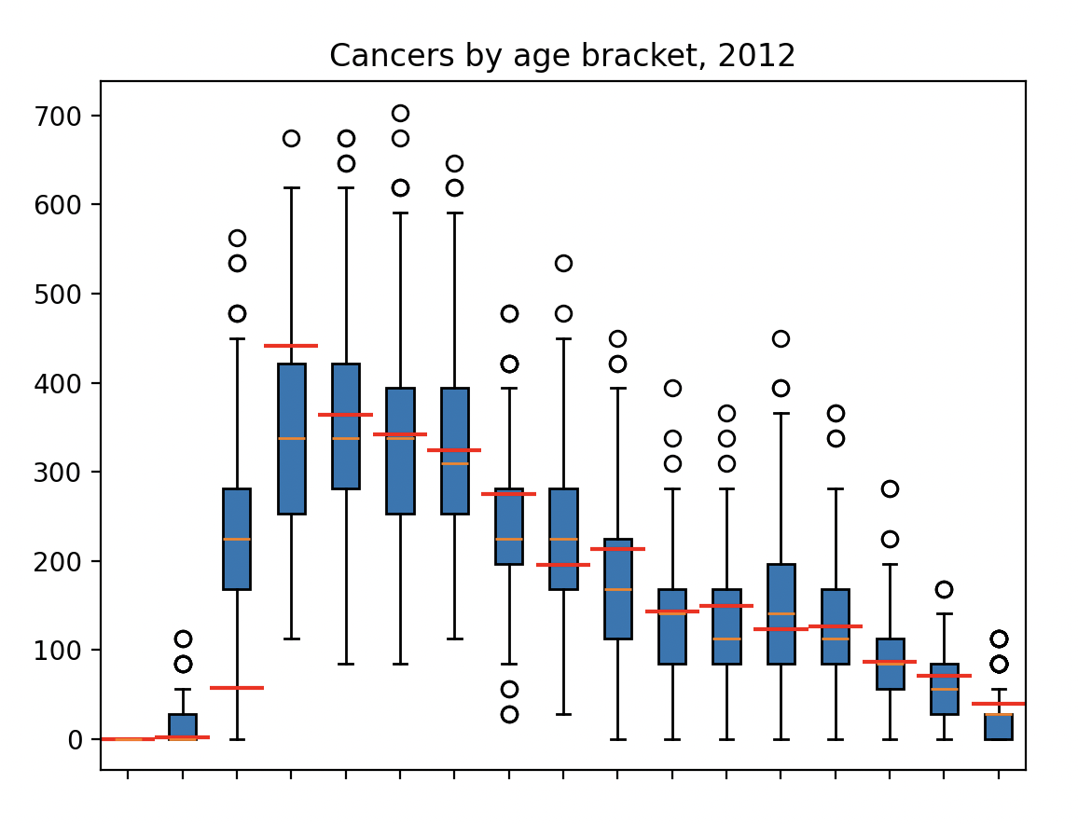

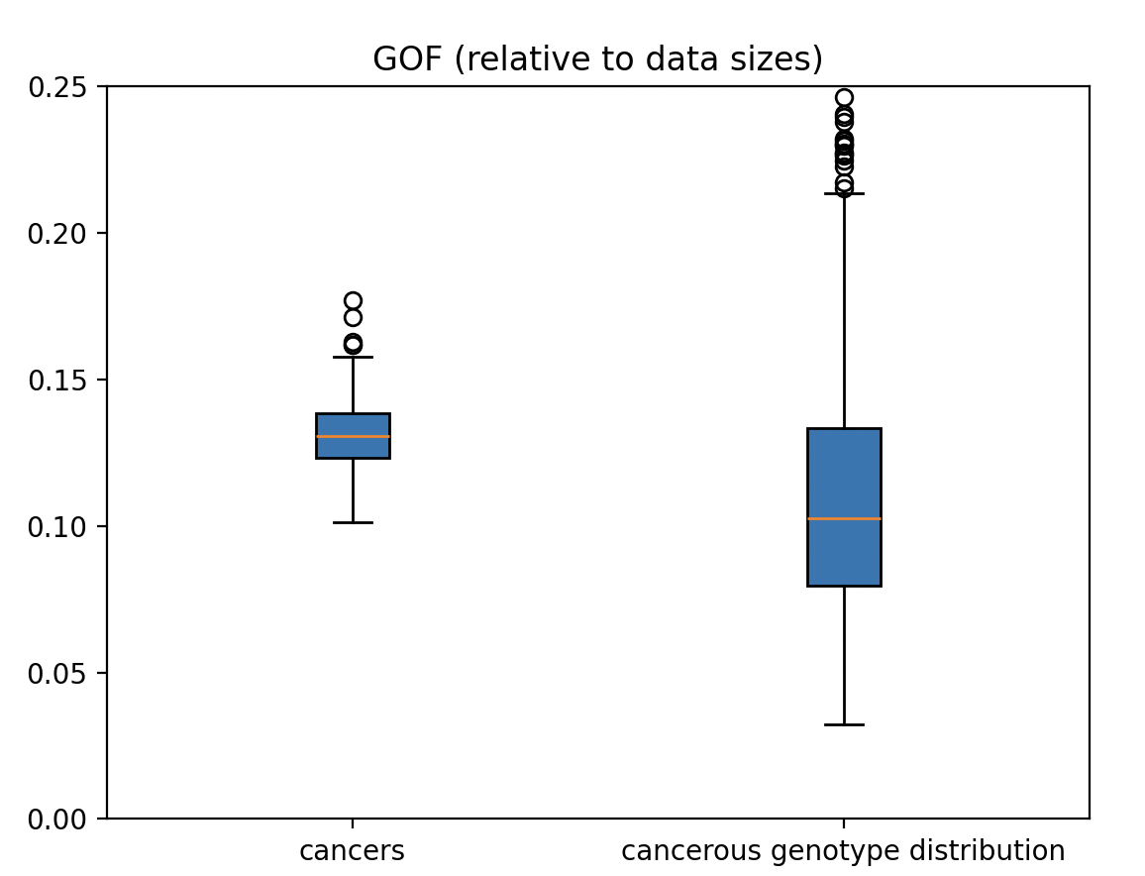

  - Fit to unseen data, 2019-2022
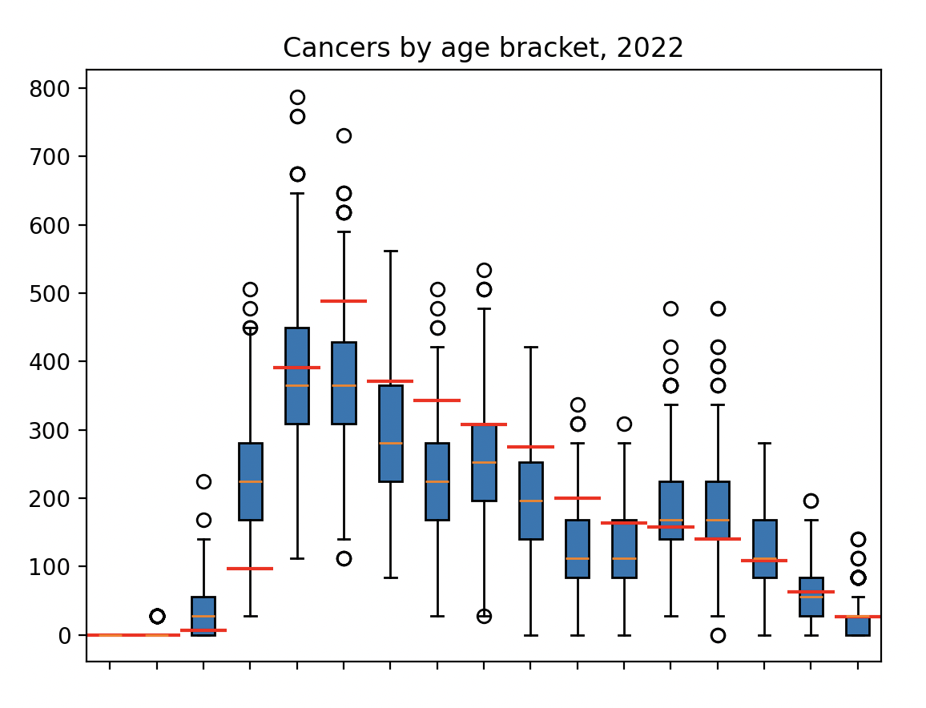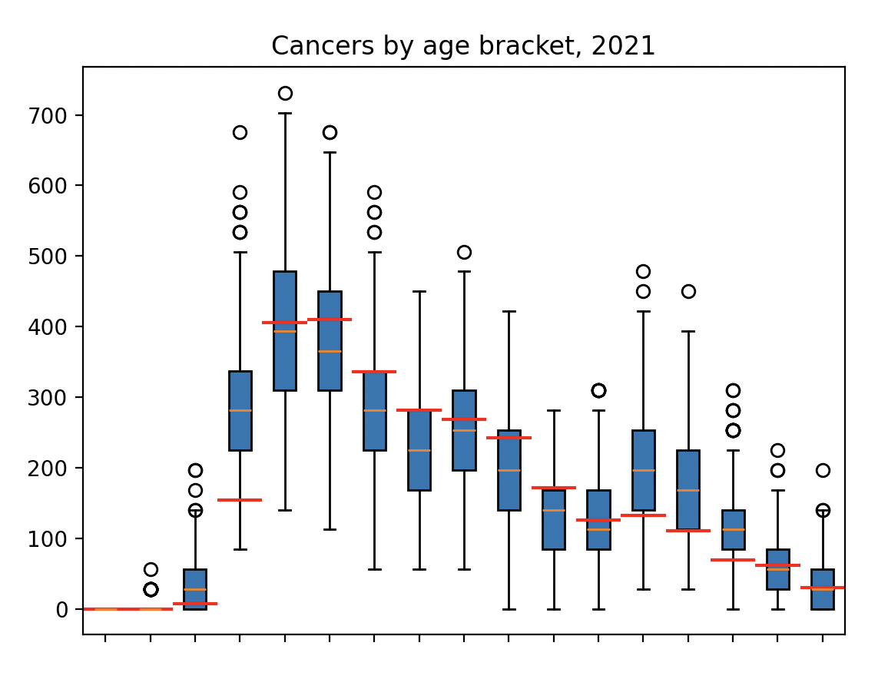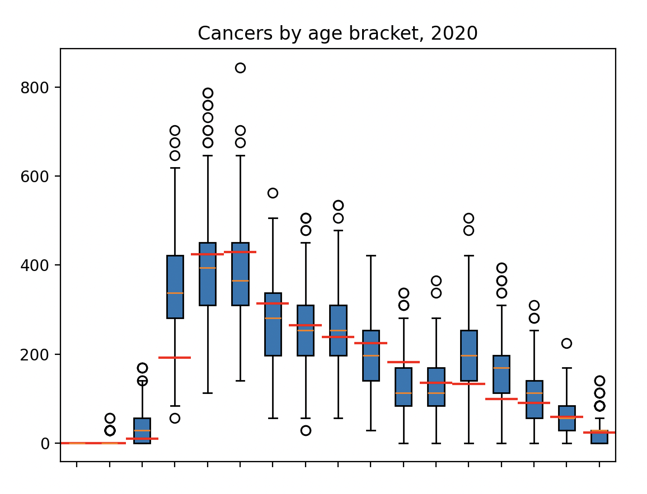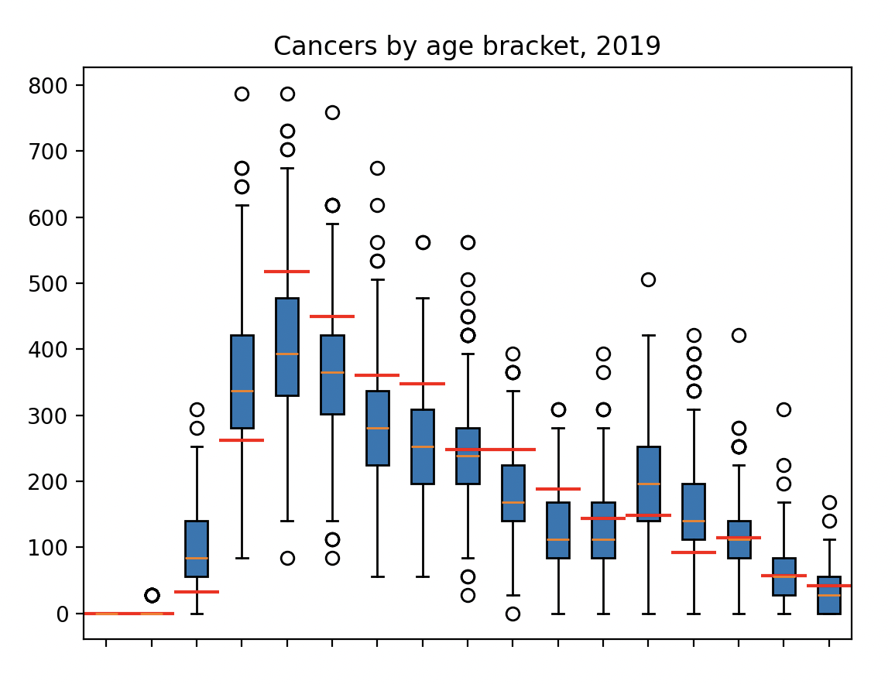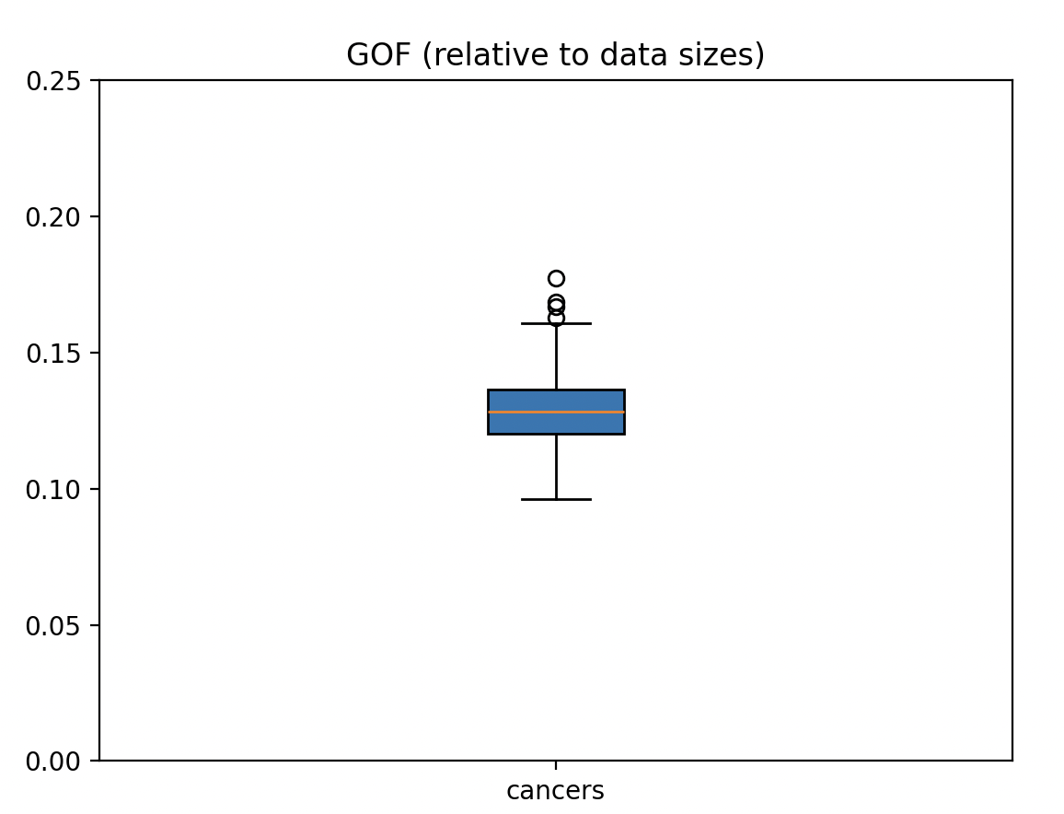

S3: HPV Prevalence
We also evaluate our model in terms of HPV 16/18 prevalence amongst 16-18, 19-21, and 22-24 year-olds against surveillance data published by the UKHSA (https://doi.org/10.1016/j.vaccine.2023.10.002), for years 2011-2020.

We observe a good fit for 16-18 year olds throughout, with a poorer fit for older age groups due to no modelling of catch-up vaccination in our model causing overestimated prevalence in these groups. However, beyond 2020 our model is re-aligned with HPV cases in these age groups, as at this time individuals born in 1995 who underwent routine HPV vaccination at ages 12-13 will be 25 years old. Therefore, for analyses focussed on predicting cancers amongst the population not offered vaccination at age 12-13 but offered catch-up vaccination as older teens/young adults, our model will overestimate cancers. However, we notice that the model aligns with observed surveillance data by the year 2020 and for the population offered vaccination at ages 12-13. For longer term projections, due to the temporary nature of this transitionary period, and the convergence of our model to the correct HPV prevalences by the early 2020s, the omission of catch-up screening may therefore be negligible.
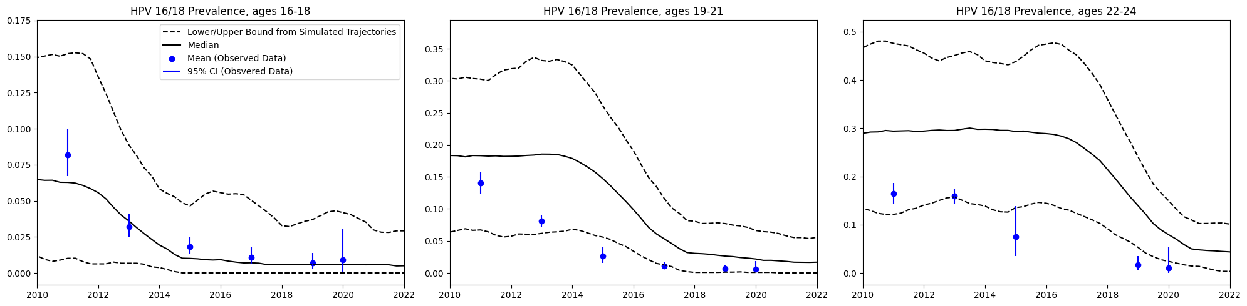

Below we plot a chart of simulated infection prevalence by age for three annual snapshots (2010, 2030, and 2050, noting 2010 is pre-vaccination). We observe the simulated effect on HPV 16/18 prevalence of vaccine-rollout, with reduced cases over the full population in younger ages and over time. We observe the effect of vaccination on reducing infection with HPV 16/18 over the full population.

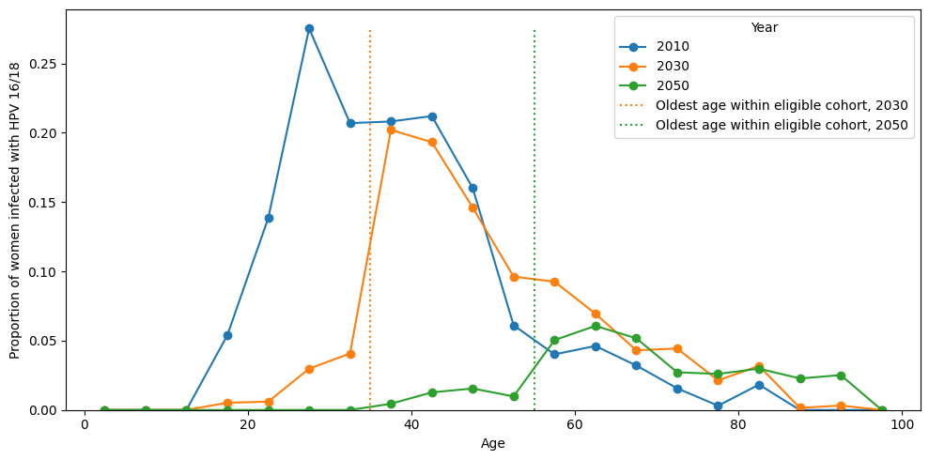

Considering the prevalence of infection with hi5 HPV genotypes included in the nonavalent vaccine over the full population, we observe a similar dampening effect.
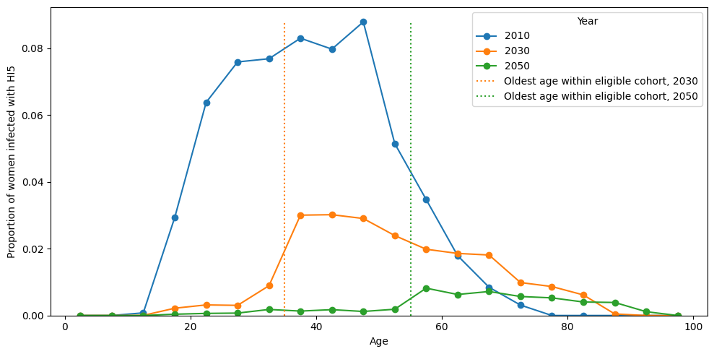
Below we consider the unvaccinated population only, and plot prevalence snapshots by age of the hi5 HPV genotypes, We observe a notable herd effect amongst those who are vaccine eligible, evident from a dampening of infections amongst this cohort.
